Thiết kế giao diện Ứng dụng chăm sóc thú cưng

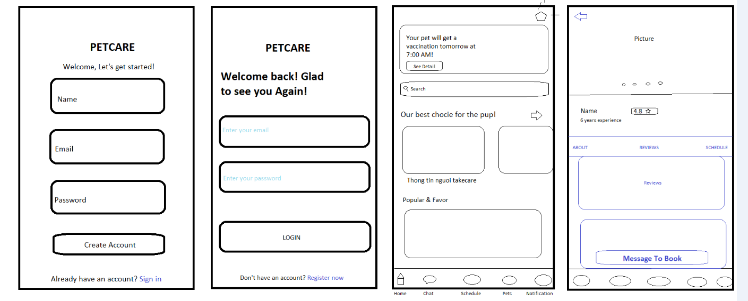

2. Thiết kế database (mySQL)

1. Bảng Users

CREATE TABLE Users (

UserID INT AUTO_INCREMENT PRIMARY KEY,

FullName VARCHAR(100) NOT NULL,

Email VARCHAR(100) UNIQUE NOT NULL,

PasswordHash VARCHAR(255) NOT NULL,

PhoneNumber VARCHAR(15),

Address VARCHAR(255),

Role ENUM('Admin', 'Customer') DEFAULT 'Customer',

CreatedAt TIMESTAMP DEFAULT CURRENT_TIMESTAMP

);

2. Bảng Pets

CREATE TABLE Pets (

PetID INT AUTO_INCREMENT PRIMARY KEY,

UserID INT NOT NULL,

Name VARCHAR(100) NOT NULL,

Species ENUM('Dog', 'Cat', 'Bird', 'Other') NOT NULL,

Breed VARCHAR(100),

DateOfBirth DATE,

PhotoURL VARCHAR(255),

HealthNotes TEXT,

FOREIGN KEY (UserID) REFERENCES Users(UserID) ON DELETE CASCADE

);

3. Bảng Appointments

CREATE TABLE Appointments (

AppointmentID INT AUTO_INCREMENT PRIMARY KEY,

UserID INT NOT NULL,

PetID INT NOT NULL,

ServiceType ENUM('Checkup', 'Vaccination', 'Grooming', 'Other') NOT NULL,

AppointmentDate DATETIME NOT NULL,

Status ENUM('Pending', 'Confirmed', 'Completed', 'Cancelled') DEFAULT 'Pending',

Notes TEXT,

CreatedAt TIMESTAMP DEFAULT CURRENT_TIMESTAMP,

FOREIGN KEY (UserID) REFERENCES Users(UserID) ON DELETE CASCADE,

FOREIGN KEY (PetID) REFERENCES Pets(PetID) ON DELETE CASCADE

);

4. Bảng Products

CREATE TABLE Products (

ProductID INT AUTO_INCREMENT PRIMARY KEY,

Name VARCHAR(100) NOT NULL,

Description TEXT,

Price DECIMAL(10, 2) NOT NULL,

Stock INT DEFAULT 0,

PhotoURL VARCHAR(255),

Category VARCHAR(100)

);

5. Bảng Orders

CREATE TABLE Orders (

OrderID INT AUTO_INCREMENT PRIMARY KEY,

UserID INT NOT NULL,

TotalAmount DECIMAL(10, 2) NOT NULL,

OrderDate TIMESTAMP DEFAULT CURRENT_TIMESTAMP,

Status ENUM('Pending', 'Processing', 'Shipped', 'Delivered', 'Cancelled') DEFAULT 'Pending',

FOREIGN KEY (UserID) REFERENCES Users(UserID) ON DELETE CASCADE

);

6 . Bảng OrderDetails

CREATE TABLE OrderDetails (

OrderDetailID INT AUTO_INCREMENT PRIMARY KEY,

OrderID INT NOT NULL,

ProductID INT NOT NULL,

Quantity INT NOT NULL,

Subtotal DECIMAL(10, 2) NOT NULL,

FOREIGN KEY (OrderID) REFERENCES Orders(OrderID) ON DELETE CASCADE,

FOREIGN KEY (ProductID) REFERENCES Products(ProductID) ON DELETE CASCADE

);

7. Bảng MedicalHistory

CREATE TABLE MedicalHistory (

HistoryID INT AUTO_INCREMENT PRIMARY KEY,

PetID INT NOT NULL,

VisitDate DATE NOT NULL,

Description TEXT NOT NULL,

Treatment TEXT,

FOREIGN KEY (PetID) REFERENCES Pets(PetID) ON DELETE CASCADE

);

8. Bảng Notifications

CREATE TABLE Notifications (

NotificationID INT AUTO_INCREMENT PRIMARY KEY,

UserID INT NOT NULL,

Message TEXT NOT NULL,

IsRead BOOLEAN DEFAULT FALSE,

CreatedAt TIMESTAMP DEFAULT CURRENT_TIMESTAMP,

FOREIGN KEY (UserID) REFERENCES Users(UserID) ON DELETE CASCADE

);